Omnisite Server Hosting Specifications

Omnisite understands that the protection of your data within our GuardDog cloud based software system is of utmost importance to your organization. To that end, we have created a hosting solution which is far superior than can be achieved by the budget of a typical facility manager. It’s not to say that it can’t be done; it can. However, it would be very expensive, and likely not practical or economical to provide your own system which would have the same protections, or level of maintenance. Following is a discussion of how Omnisite protects your critical data. For additional information or questions, refer them to Tom Ward, President, Omnisite email: tward@omnisite.com

The Hosting Facility

Omnisite does not publically divulge the location or type of our hosting facilities. This is done for your protection. However, if you require a tour of the facilities, please address your request to Tom Ward (noted above), and we can accommodate any reasonable request. Omnisite’s server hosting has been reviewed by the Verizon Wireless CyberSecurity Team and deemed to be acceptable to their standards

Data Suite
The data suite consists of:
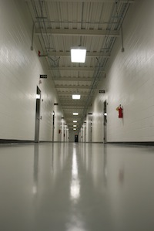

A secured hall provides biometrical-secure access to the data suite.
- dedicated HVAC
- dedicated fire suppression
- dedicated electrical distribution systems.
All supporting equipment for the data suite is located in a separate maintenance hallway, accessible only to approved staff. This means access to critical infrastructure is tightly controlled, and also means that personnel are not entering the data suites more often than necessary.

Fire Suppression
Each suite has its own dedicated gaseous based fire suppression system. By utilizing a gaseous based system, overhead water based sprinkler are lines out of the data center area.

Electrical Infrastructure
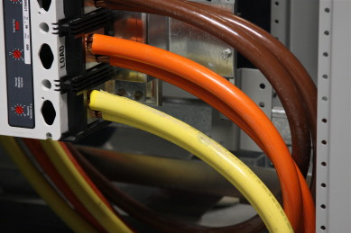
The electrical infrastructure of facility was purposely designed for maximum electrical availability.
The facility was designed for 10 Megawatts of incoming redundant utility power (20 total MW available non-redundant).

Quadrant Design
Each quadrant of the facility is serviced by completely independent equipment, including:

- Two 2.5MVA electrical transformers, from separate utility feeds
- Two 2MW Cummins diesel powered generators
- Electrical switchgear to control and balance the power, including transient surge suppression.

UPS Power
Each quadrant’s critical IT load is backed up by 2 ActivePower flywheel UPS systems, providing:
- Isolation from the incoming power grid
- Very clean sinusoidal output, protecting against spikes and surges in the incoming power
- Ride-through time of 30+ seconds in case of a power outage. Providing a smooth transition for generators and other UPS systems to take over

Data Suite PDUs
Each data suite has two dedicated, redundant PDUs fed from the UPS systems, each providing another level of transient voltage surge suppression to the critical IT loads.

Cooling Infrastructure
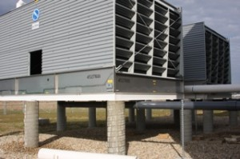
Redundant cooling towers provide heat rejection from critical IT loads.
The cooling systems design is highly efficient, and maximally redundant. A number of inter-working systems provide constant heat rejection from the data suite to the outside atmosphere.

Liebert Chilled Water CRACs
Each data suite has dedicated redundant Liebert chilled water CRAC units supplying a constant supply of humidity and temperature controlled air. The units communicate with each other to ensure an optimal operating environment.
Chilled Water Loops
All Liebert units are fed from a pair of redundant chilled water pipe loops, with valves in place to allow redirection of water flow and distribution at any time.
Having a redundant set of pipe loops allows for system fail-over should any aspect of the piping system develop a leak.
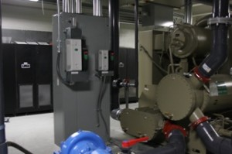
Internal redundant chilled water systems provide ample cooling around the facility.
Chilled Water Creation
Each quadrant of the facility is serviced by a highly efficient pair of redundant Trane water cooled chillers, including redundant pumping systems. These computer controlled units operate at high efficiency and offer substantial chilling capacities for the critical IT loads.

Connectivity Infrastructure

The facility is well connected, with all new fiber optic installation and equipment.
Fiber Rings
The is on a number of fiber rings, for multiple redundant paths in/out of the facility.
Redundant Entrances
Fiber optic lines enter the facility into two different telecom rooms located at opposite sides of the building. From there, network connectivity is routed either underground or overhead to the data suite.
Multiple Carriers
Multiple carriers enter the building via diverse pathways, with four separate exit directions. The facility is carrier neutral and maintains upstream peering relationships with vendors such as AT&T, Level3, and WV Fiber.

Connectivity Providers
As a carrier neutral data center facility, the facility boasts an impressive portfolio of connectivity providers listed below. By combining these providers with our impressive connectivity infrastructure, we experience low latency and high performance connectivity services.

Preferred Carriers

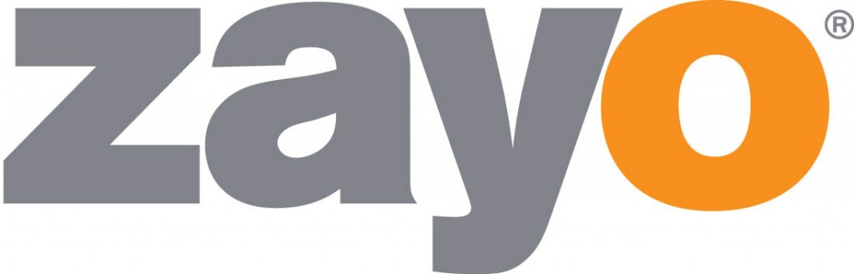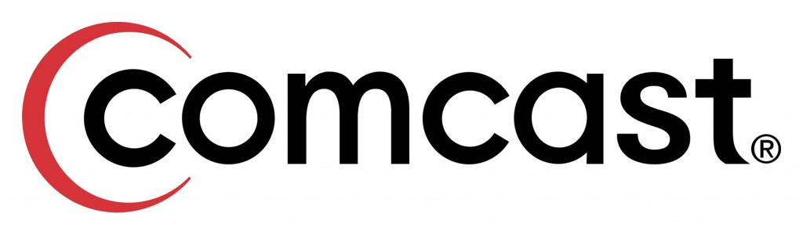






Other Carrier Presence








Compliance and Certifications
The facility is compliant with today’s data center standards and regulations, and we can help your organization meet your own compliance needs as well, as they relate to uptime and equipment security.
Key compliance standards:
Tier IV

SSAE-16

HIPAA and HITECH

To learn more about these compliance standards, and how we meets them, contact Tom Ward, President, Omnisite

Disaster Recovery

Disaster Recovery Planning: Your Insurance when Disaster Strikes
Disaster is uncontrollable and often unpredictable – fire, floods, tornados and even power outages are just a few ways your business can be disrupted. Both natural disasters and disasters related to human error can be detrimental to running your business, and disaster recovery (DR) can be a hassle when you are forced to define solutions in the midst of calamity.
Having a disaster recovery plan can relieve some of the stress associated with recuperating from unexpected events, and keeping your monitoring systems operational for your customers. Think of it as insurance for getting your systems up and running again and maintaining the security of your data and important information. Because your GuardDog data is hosted off site in a multiple redundant facility (which also backs up that data, again offsite), your data is protected from a disaster at your facility, regardless of the type; natural disaster or employee vandalism. Anywhere in the world where you

can reach the Internet with a smart phone, tablet or personal computer, you can again have immediate access to your data, should your facility incur a disaster.
The ultimate piece of mind. However, piece of mind does not stop there. The GuardDog software also backs-up your data in real-time all day long each day. In the event of a disaster, there are no more concerns of recovering data from damaged PC’s on site. This is done for you automatically as part of your annual subscription fee to Omnisite’s services. Your annual subscription fee to Omnisite acts as not only your wireless connection to your critical equipment, but also protects critical data that can be difficult to preserve during a disaster situation. Our tech support is standing-by 24/7 , at no additional charge for subscribed customers, to guide you through any problem; even a disaster.

Creating a Plan for Recovery
There are certain questions you should have at the top of your mind when you are preparing for disaster.
- What data is most important to your business operations?
- How long can your business operate without the availability of critical data?
- What type of disaster is likely to occur in your area and how can you prepare?
- What offsite backup accommodations have been made for your systems?
- What is the cost comparison between recovering from disaster and investing in a recovery plan?
Omnisite provides this plan for your Omnisite data. There’s nothing else for you to do.

What Planning Ahead Means for Your Business
- Reduced risk for human disaster
- Guaranteed availability of backup systems
- Connectivity during outage
- Minimized business downtime
- Positive customer experiences, even during disaster

Business Continuity
Being able to continue operations after a major disaster is important to any business. A business continuity plan can be the piece of the puzzle that keeps your critical business functions available even if your offices or equipment are not accessible. Business continuity planning usually arises when you are developing your disaster recovery plan,

and should include things like a business redemption plan, business recovery plan and a contingency plan. When you are constructing your plans, you want to consider identifying a secondary worksite that can be set up for your employees or a team of your staff to continue working. With Omnisite’s data, this is done for you; however, you’ll want to have a similar plan for your local facilities
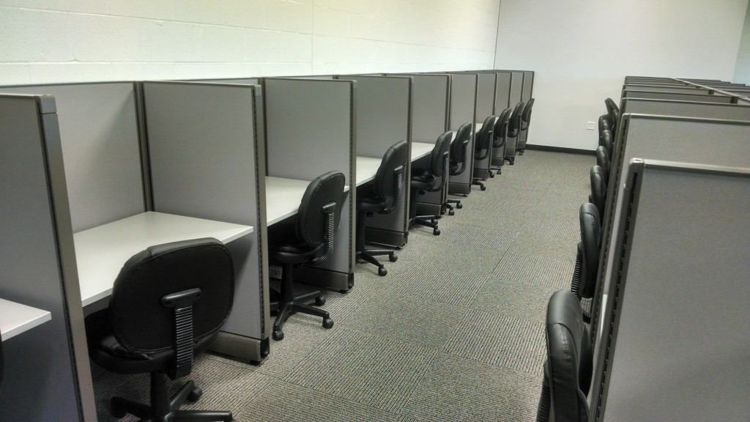
Having a place for your key personnel to work can be the difference between shutting down your business after the interruption and continuing to conduct business as usual. Proper planning also helps build customer confidence in your operations, and it can even give you a competitive advantage. For organizations that are regulated by compliance, business continuity can help you maintain legal and other such requirements. The most significant benefit is, of course, continued operations
At Omnisite, we maintain a 24 seat onsite workspace dedicated to our business continuity at our remote hosting facility should our administrative headquarters incur a disaster. So in the case of a disaster at our primary headquarters, we can relocate our tech support personnel to our remote hosting facility so that they can continue to support you 24/7.
About the Center
- 24 seats available, with space for expansion
- Space is available 24/7/365 (with 24 hours turnaround)
- Cross connect to any equipment stored at the facility
- Includes a private conference room
- Chair lift is built in for easy access
- Located within a hardened and secure facility
Don’t find yourself unprepared for a disaster. Power or connectivity losses don’t have to mean a disruption of your business. Omnisite’s Business Continuity Plan ensures your data and support is always ready when you need it. Contact us today to learn more about how we can help you stand in the midst of disaster.

Offsite Backup
Your business relies on electronic data. Imagine losing all of your data simply from a computer or server hard drive failure. What is your backup plan? Can your business survive? Having an offsite backup solution is a proactive way to secure the most important information to your business and to maintain business continuity.
At Omnisite our comprehensive offsite backup services are designed to run in the background in the cloud and provide real time data replication to a secure server within our data center. So whether disaster strikes or you suffer an equipment failure, we can restore your data anytime, anywhere. And there is no need to buy any additional hardware. We provide everything you need for offsite data storage.
- Customizable backup solutions. Whether you want your data updated and backed up every minute or once a week, we’ve got you covered
- Extremely affordable price points. Our “no hidden fees” agreement supplies automatic data backups, wireless service, and technical support all without hidden surcharges or unexpected price increases
- Fast and easy setup. Within five minutes you can have the GuardDog website up and running on your machine.
- No charge to recover data. Many solutions charge a hefty fee to retrieve your data. At Omnisite, the moment your systems fails, you can focus on getting your systems back up and running instead of worrying about the cost of data recovery.
Having a backup site should be hassle free and reliable, allowing you to rest easy knowing that your data is being backed up in a secure location. Whether you are choosing offsite backup as a means of disaster recovery or another layer of redundancy, Omnisite can offer an option that gives you the peace of mind you need. We like to think in terms of how your business benefits so here are a few advantages of choosing Omnisite for your offsite backup solution.
- No need to purchase additional hardware
- Protection for your data 24/7
- Compatible with Windows, Mac, Linux
- Disaster recovery protection
- Customizable options to meet your needs
- Single or double encryption
- One flat fee, no hidden charges
- Technical support from Omnisite staff or one of our trusted partners
Top 10 Frequently Asked Questions:
What is the level of redundancy at the Omnisite Hosting facility?

We have a very high level of redundancy in virtually every infrastructure aspect of our data center. This includes our cooling systems, power supply, and emergency backup generators. These measures have resulted in a level of 99.999% uptime for our clients, during the entire time we have been in operation.
How has the facility been engineered to withstand disasters such as tornadoes, floods, and earthquakes?
The facility was carefully constructed to withstand a wide range of disasters, including tornadoes, floods, and earthquakes:
a) The building was constructed with oversized concrete block and nearly 1″ diameter rebar, and it is rated to withstand the hit of an EF-5 tornado or 200+ mph winds.
b) The facility is not located within any floodplain, based on the official flood mappings from both FEMA* and the Department of Natural Resources.*
c) The facility is located outside of any major seismic zones, based on extensive ground sample testing that was done prior to and during the facility’s construction. It is also is not located near any active fault lines.
Why did you choose UPS Flywheels over batteries?
We chose UPS flywheels over batteries for several reasons: they require less space than batteries, they don’t need to be replaced regularly as batteries do, flywheels don’t have stringent cooling requirements, and they are more environmentally friendly than batteries (since flywheels contain no chemicals). While flywheels typically provide less runtime than battery systems (approximately 45-60 seconds compared to upwards of 15 minutes provided by batteries), our backup generators routinely start up in less than 10 seconds. Thanks to this high level of efficiency, we have seen no issues whatsoever with the runtime for our UPS flywheels.
Why are there no raised floors in your suites?

Like many modern data centers, the facility does not use raised floors. One of the primary reasons for this design is that we are able to see much more cooling efficiency when a raised floor is not used (we instead opted for overhead duct based cooling).
How is your equipment and facility monitored?

We utilize a combination of proprietary and open source software to regularly monitor all of our critical equipment.
What carriers are on-site/built-in?
The facility has connectivity through several of the largest providers, including Comcast, Smithville, AT&T, Windstream, and others.
Can I have physical access to my equipment at anytime?
Any company employee who has been authorized by you will have 24/7 access to your colocated equipment/data. Once they are setup with the proper access credentials, they can enter the facility escorted. We can also provide any vendors with access to your equipment but only with express permission from you ( in the form of written authorization).
What other services do you offer?
Omnisite manufactures wireless data collection and control systems for municipal, industrial, and residential clients. Some of our residential solutions are sold in popular places like the Home Depot, Amazon, Sears, and Verizon Wireless retail stores. Please contact us if you want more information on how we can help monitor your next project.
Who are some of your customers?
Omnisite’s municipal customer list reads like a Who’s Who in the water and wastewater industry. We have several thousand US customers which we can supply as references. Our products are sold by authorized factory trained representatives across the USA. We can provide a customer list for your location upon request

